Supplementary Materials for
Emotion and intergroup cooperation: How expressions of guilt, shame and pride influence behavior in the centipede game

Samuel J. Nunney, Job van der Schalk, and Antony S. R. Manstead
Cardiff University, UK

Study 1 Game Behavior Raw Data
“S” denotes that the group stole, and the accompanying number denotes the round number on which they exited. “C” denotes a fully completed round

Instructions to participants
(for both Studies 1 and 2, with differences between the studies italicised)
Dear Group A/B.
Description: In this study, we are interested in looking at how groups cooperate and compete in the Intergroup Cooperation Game.
You have been placed in this group based upon your answers to the previous screening questionnaire.
In the Intergroup Cooperation Game, you and the other group will make a series of decisions in alternating order. At each stage, the group with the decision will have to choose to STOP or CONTINUE, thus, passing the same decision onto the other group. This will continue until one group chooses to stop or until the final completed stage of each game is reached. There will be payoffs in the form of lottery tickets, determined by what stage the process stops and who stops it. The group who chooses to stop will earn more lottery tickets, but the lottery ticket numbers increase with successive stages.
There will be six [two] individual games played in the first instance, followed by a break in which you will be able to express your emotions to the opposing group, a further six [two] games will follow this.
Prior to the first official game beginning, you will be able to play a ‘practice game’ against the computer.
This study takes between 30 and 45 minutes, and upon completion you will receive your allocated course credit and final number of lottery tickets.

Instructions when logging on to the Intergroup Cooperation Game:
(Studies 1 and 2, with differences between the two italicised)
This program sets up an Intergroup Cooperation Game in which two groups make a series of decisions in alternating order. At each stage in the series, the group who is taking the decision must choose to stop or continue. The process continues until one group chooses to stop or until the final stage is reached. Payoffs are determined by the stage at which the process stops. The group who chooses Stop earns more than the other group, but payoffs typically increase with successive stages.
Rounds: This experiment consists of a number of rounds. The number of rounds is: 12 (a first phase of 6, a break, and a second phase of 6) [The number of rounds is: 4 (a first phase of 2, a break, and a second phase of 2)].
Interdependence: Your lottery ticket earnings are determined by the decisions that you and the other group make. Each of you will be given the chance to make one or more decisions, in alternating order, until one group stops the process or until the final decision point is reached and the process is stopped automatically.
Roles: In each pair of groups, one group will make the initial decision. If this group does not stop the process, then the other group will make the second decision. This group may stop the process, etc.
Payoffs: Press ‘Continue’ to see the table of lottery ticket payoffs on the next page.
Before beginning: After viewing the lottery ticket payoff on the next page, you will be invited to take part in a practice game.

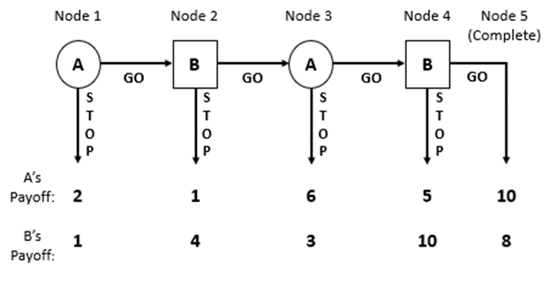

Dependent Measures
Emotion Expression
(Studies 1 and 2, but only ‘proud’ and ‘ashamed’ were used in Study 2)
This information will be shared with the other group.
How are you now feeling, as a group, about your performance in phase 1?
Proud
Strongly Disagree | Disagree | Slightly Disagree | Slightly Agree | Agree | Strongly Agree
1 | 2 | 3 | 4 | 5 | 6

Guilty
Strongly Disagree | Disagree | Slightly Disagree | Slightly Agree | Agree | Strongly Agree
1 | 2 | 3 | 4 | 5 | 6

Ashamed
Strongly Disagree | Disagree | Slightly Disagree | Slightly Agree | Agree | Strongly Agree
1 | 2 | 3 | 4 | 5 | 6

Altruistic Punishment
(Study 2 only, completed by participants as individuals)
If you could give up any number of your group’s tickets to remove double that amount of your opponents’ tickets, how many tickets would you give up?

